NAME :- Manish Shashikant Jadhav
UID :- 2023301005.
BRANCH :- Comps -B. BATCH: B.
EXPERIMENT 9: To examine integrity of database using Triggers.
SUBJECT :- DBMS (DATABASE MANAGEMENT SYSTEM)

- What is trigger in the database? Why are triggers used in databases?

A trigger is a set of instructions that are automatically executed, or "triggered," in response to certain events on a particular table or view. These events can include operations such as INSERT, UPDATE, DELETE, and sometimes even SELECT. Triggers are defined to execute a specified action, such as modifying data in other tables, enforcing business rules, or logging changes.
Here are some key points about triggers and their use in databases:
Event-Driven Execution: Triggers are event-driven, meaning they are executed in response to specific events occurring in the database. For example, a trigger may be set to execute after an INSERT operation on a table.
Types of Triggers:
BEFORE Triggers: These triggers execute before the triggering event (e.g., BEFORE INSERT).
AFTER Triggers: These triggers execute after the triggering event (e.g., AFTER UPDATE).
INSTEAD OF Triggers: These triggers replace the triggering event. For example, instead of performing the default action for an INSERT, an INSTEAD OF trigger can be defined to perform a different action.
Use Cases:
Enforcing Business Rules: Triggers can be used to enforce business rules by checking and validating data before it is inserted, updated, or deleted.
Referential Integrity: Triggers can help maintain referential integrity by automatically updating related tables when changes are made to a primary table.
Logging and Auditing: Triggers can be employed to log changes made to the database, providing an audit trail for tracking modifications.
Automated Calculations: Triggers can perform calculations or generate derived data based on changes in other data.
Benefits:
Consistency: Triggers help ensure data consistency and integrity by automatically enforcing rules and actions.
Automation: They automate repetitive tasks, reducing the need for manual intervention and minimizing the chances of human error.
Security: Triggers can contribute to security by logging changes and facilitating auditing.
Considerations:
Performance: Poorly designed triggers can impact performance, so it's important to consider the efficiency of trigger logic.
Complexity: Overuse of triggers or complex trigger logic can make the database schema and behavior more difficult to understand and maintain.

- Create a table Uni_Audit

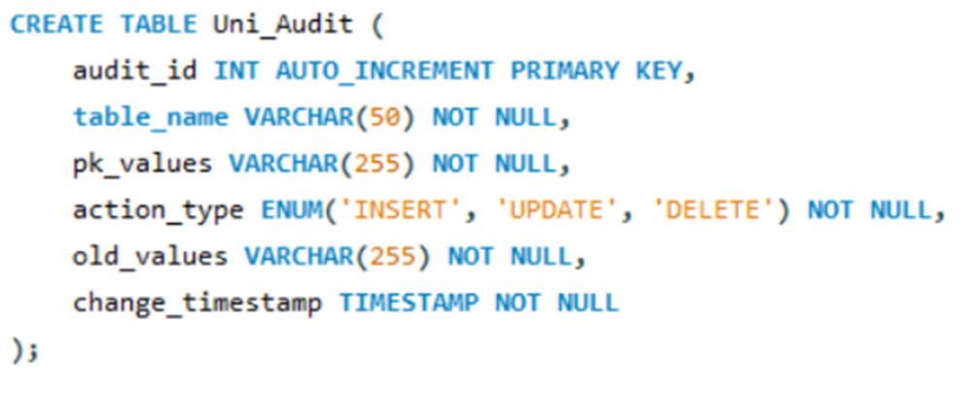

- Write any five triggers for the university database using MySQL.

- AFTER INSERT : This trigger creates an audit trail by logging information about the newly inserted instructor record in the Uni_Audit table after the actual insertion takes place. The trigger is using the NEW keyword to access the values of the columns in the new row being inserted.
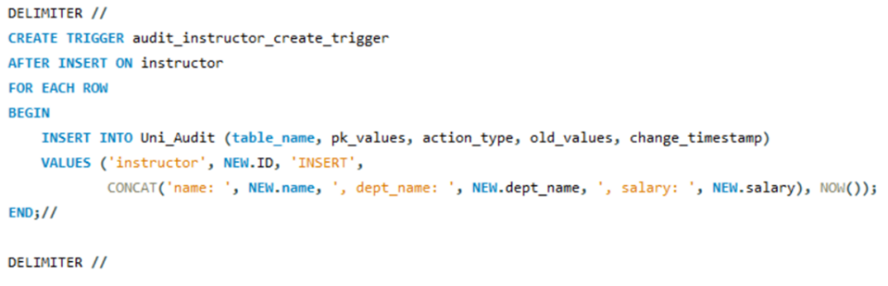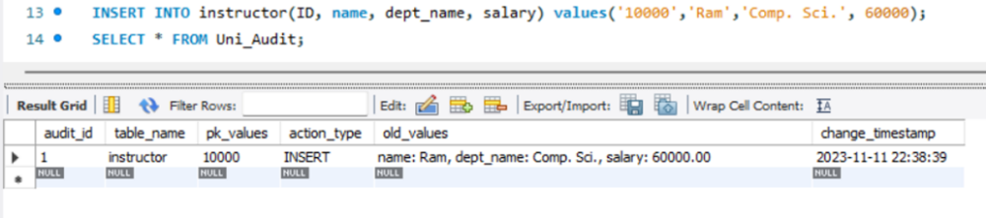

2. BEFORE INSERT : This trigger creates an audit trail by logging information about the new section record in the Uni_Audit table before the actual insertion takes place. The trigger is using the NEW keyword to access the values of the columns in the new row being inserted.
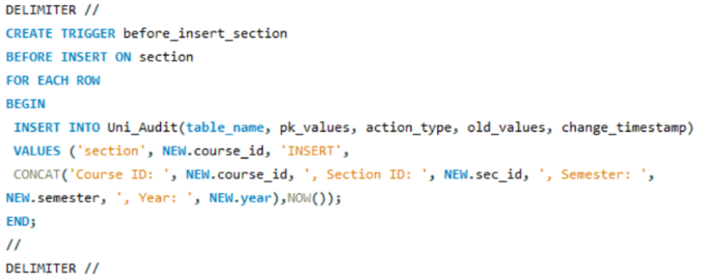
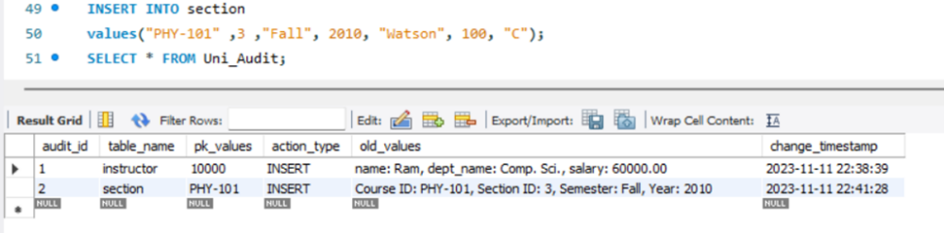

3. AFTER DELETE : This trigger captures the old values of the deleted row in the 'course' table and inserts them into the Uni_Audit table. The trigger execution time (change_timestamp) is also recorded.
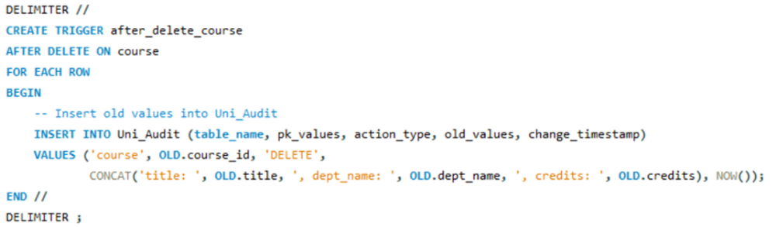
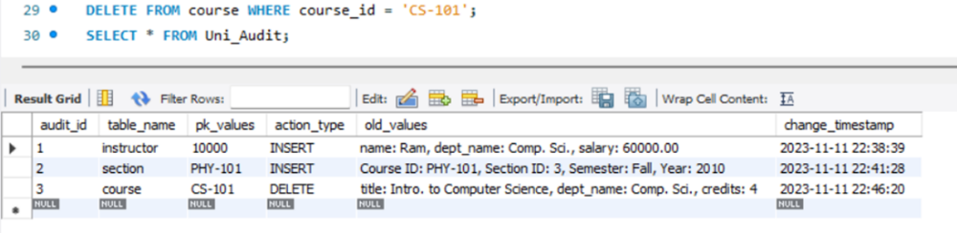

4. BEFORE DELETE : This trigger captures the old values of the deleted row in the 'student' table and inserted them into the Uni_Audit table. The trigger execution time (change_timestamp) is also recorded.

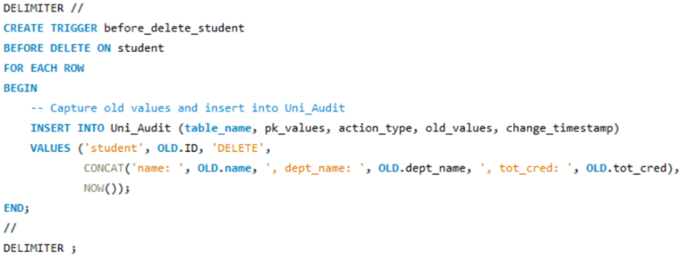
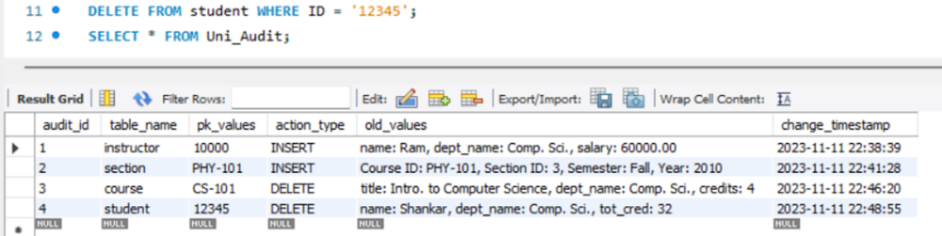
5. BEFORE UPDATE : This trigger captures the old values of the 'instructor' table before an update and inserts them into the Uni_Audit table, including the primary key (ID), action type ('UPDATE'), old values, and the timestamp of the change
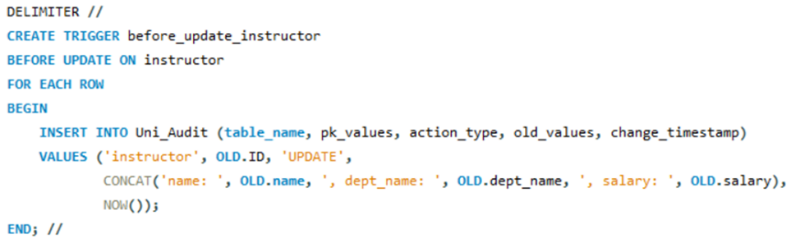
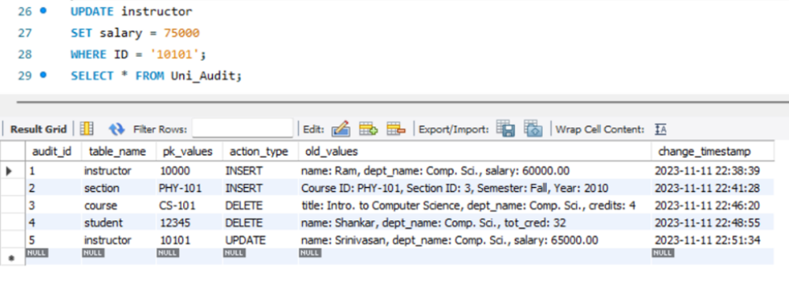

Conclusion: Hence by completing this experiment I came to know about triggers in database.

